Experiment 3

<!DOCTYPE html>
<html>
<head>
<title> program to reverse,replace a character of a string and check whether entered string is Palindrome in JavaScript </title>

<style>
h1 {
text-align: center;
padding: 100px;
background-color: rgba(255, 174, 0, 0.733);
color: rgba(44, 11, 231, 0.849)
}

.palin {
margin: 30px;
width: 80%;
border: 3px solid rgb(138, 9, 9);
border-radius: 5px;
padding: 50px;
}

#pa2 {

width: 50%;
border: 3px solid orangered;
border-radius: 5px;
padding: 5px;
}

#ra {

width: 50%;
border: 3px solid orangered;
border-radius: 5px;
padding: 5px;
}

#rc {

width: 50%;
border: 3px solid orangered;
border-radius: 5px;
padding: 5px;
}

</style>

</head>
<body>

<h1> Program to reverse,replace a character of a string and check whether entered string is Palindrome in JavaScript </h1>
<div class="palin">
<label> Enter any string or number : </label>
<input id= "pa"> <br> <br>
<label> Reverse of a string : </label>
<input id= "ra"> <br> <br>
<label> Replace charcter r with b : </label>
<input id= "rc"> <br> <br>
<label> Resultant string : </label>
<input id = "pa2" > </b> <br>
<button onclick= "reverseString();replacestring();palindrome();" >Submit</button> <br>
</div>

<script type = "text/javascript">
function reverseString()
{
var a= document.getElementById("pa").value;

var newString = "";
for (let i = a.length - 1; i >= 0; i--)
{
newString += a[i];
}
document.getElementById("ra"). value = newString + " ";
}

function replacestring()
{
var a= document.getElementById("pa").value;
const regex = /r/g;
var newText1 = a.replace(regex, 'b');
document.getElementById("rc"). value = newText1 + " ";
}

function palindrome()
{
var a= document.getElementById("pa").value;
// get the total length of the words

var b="";
// Use for loop to divide the words into 2 half
for (let i = a.length-1; i >=0; i--)
{
b+=a[i];
}
// validate the first and last characters are same
if (a==b)
document.getElementById("pa2"). value = b + " is a Palindrome String ";
else
document.getElementById("pa2"). value = b + " is not a Palindrome String";
}

</script>
</body>
</html>

<!DOCTYPE html>
<html>
<head>
<title> program to reverse,replace a character of a string and check whether entered string is Palindrome in JavaScript </title>

<style>
h1 {
text-align: center;
padding: 100px;
background-color: blue;
color: white
}

.palin {
margin: 30px;
width: 80%;
border: 3px solid rgb(138, 9, 9);
border-radius: 5px;
padding: 50px;
}

#pa2 {

width: 50%;
border: 3px solid orangered;
border-radius: 5px;
padding: 5px;
}

#ra {

width: 50%;
border: 3px solid orangered;
border-radius: 5px;
padding: 5px;
}

#rc {

width: 50%;
border: 3px solid orangered;
border-radius: 5px;
padding: 5px;
}

</style>

</head>
<body>

<h1> Program to reverse,replace a character of a string and check whether entered string is Palindrome in JavaScript </h1>
<div class="palin">
<label> Enter any string or number : </label>
<input id= "pa"> <br> <br>
<label> Reverse of a string : </label>
<input id= "ra"> <br> <br>
<label> Replace charcter r with b : </label>
<input id= "rc"> <br> <br>
<label> Resultant string : </label>
<input id = "pa2" > </b> <br>
<button onclick= "reverseString();replacestring();palindrome();" >Submit</button> <br>
</div>

<script type = "text/javascript">
function reverseString()
{
var a= document.getElementById("pa").value;

var newString = "";
for (let i = a.length - 1; i >= 0; i--)
{
newString += a[i];
}
document.getElementById("ra"). value = newString + " ";
}

function replacestring()
{
var a= document.getElementById("pa").value;
const regex = /r/g;
var newText1 = a.replace(regex, 'b');
document.getElementById("rc"). value = newText1 + " ";
}

function palindrome()
{
var a= document.getElementById("pa").value;
// get the total length of the words

var b="";
// Use for loop to divide the words into 2 half
for (let i = a.length-1; i >=0; i--)
{
b+=a[i];
}
// validate the first and last characters are same
if (a==b)
document.getElementById("pa2"). value = b + " is a Palindrome String ";
else
document.getElementById("pa2"). value = b + " is not a Palindrome String";
}

</script>
</body>
</html>

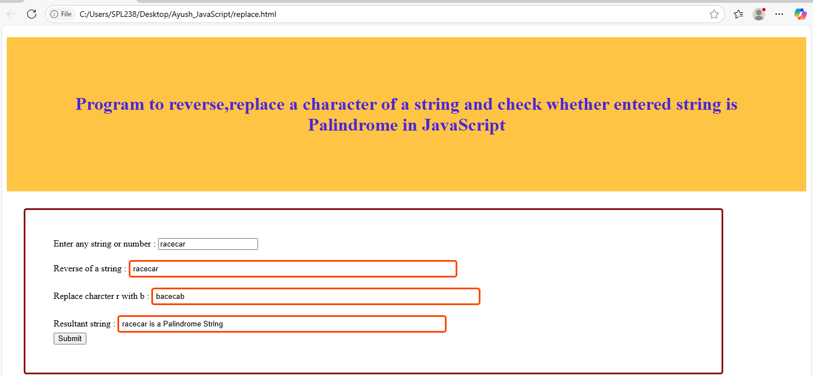

Reverse of a String:
<!DOCTYPE html>
<html>
<head>
<title> program to reverse,replace a character of a string and check whether entered string is Palindrome in JavaScript </title>

<style>
h1 {
text-align: center;
padding: 100px;
background-color: rgba(255, 174, 0, 0.733);
color: rgba(44, 11, 231, 0.849)
}

.palin {
margin: 30px;
width: 80%;
border: 3px solid rgb(138, 9, 9);
border-radius: 5px;
padding: 50px;
}

#pa2 {

width: 50%;
border: 3px solid orangered;
border-radius: 5px;
padding: 5px;
}

#ra {

width: 50%;
border: 3px solid orangered;
border-radius: 5px;
padding: 5px;
}

#rc {

width: 50%;
border: 3px solid orangered;
border-radius: 5px;
padding: 5px;
}

</style>

</head>
<body>

<h1> Program to reverse a String in JavaScript </h1>
<div class="palin">
<label> Enter any string or number : </label>
<input id= "pa"> <br> <br>
<label> Reverse of a string : </label>
<input id= "ra"> <br> <br>

<button onclick= "reverseString();" >Submit</button> <br>
</div>

<script type = "text/javascript">
function reverseString()
{
var a= document.getElementById("pa").value;

var newString = "";
for (let i = a.length - 1; i >= 0; i--)
{
newString += a[i];
}
document.getElementById("ra"). value = newString + " ";
}

</script>
</body>
</html>
<!DOCTYPE html>
<html>
<head>
<title> program to reverse,replace a character of a string and check whether entered string is Palindrome in JavaScript </title>

<style>
h1 {
text-align: center;
padding: 100px;
background-color: rgba(255, 174, 0, 0.733);
color: rgba(52, 199, 209, 0.76)
}

.palin {
margin: 30px;
width: 80%;
border: 3px solid rgb(138, 9, 9);
border-radius: 5px;
padding: 50px;
}

#pa2 {

width: 50%;
border: 3px solid orangered;
border-radius: 5px;
padding: 5px;
}

#ra {

width: 50%;
border: 3px solid orangered;
border-radius: 5px;
padding: 5px;
}

#rc {

width: 50%;
border: 3px solid orangered;
border-radius: 5px;
padding: 5px;
}

</style>

</head>
<body>

<h1> Program to reverse a String in JavaScript </h1>
<div class="palin">
<label> Enter any string or number : </label>
<input id= "pa"> <br> <br>
<label> Reverse of a string : </label>
<input id= "ra"> <br> <br>

<button onclick= "reverseString();" >Submit</button> <br>
</div>

<script type = "text/javascript">
function reverseString()
{
var a= document.getElementById("pa").value;

var newString = "";
for (let i = a.length - 1; i >= 0; i--)
{
newString += a[i];
}
document.getElementById("ra"). value = newString + " ";
}

</script>
</body>
</html>

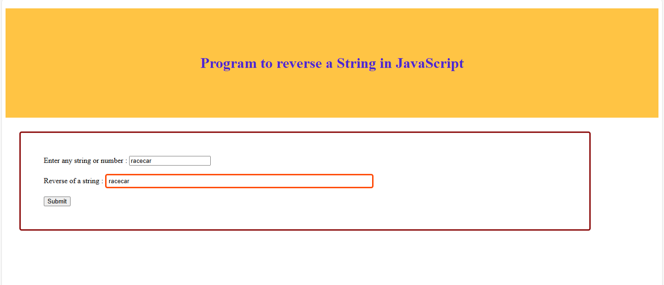

Reverse of a String:

<!DOCTYPE html>
<html>
<head>
<title> program to reverse,replace a character of a string and check whether entered string is Palindrome in JavaScript </title>

<style>
h1 {
text-align: center;
padding: 100px;
background-color: rgba(255, 174, 0, 0.733);
color: rgba(44, 11, 231, 0.849)
}

.palin {
margin: 30px;
width: 80%;
border: 3px solid rgb(138, 9, 9);
border-radius: 5px;
padding: 50px;
}

#pa2 {

width: 50%;
border: 3px solid orangered;
border-radius: 5px;
padding: 5px;
}

#ra {

width: 50%;
border: 3px solid orangered;
border-radius: 5px;
padding: 5px;
}

#rc {

width: 50%;
border: 3px solid orangered;
border-radius: 5px;
padding: 5px;
}

</style>

</head>
<body>

<h1> Replace a character of a string in JavaScript </h1>
<div class="palin">
<label> Enter any string or number : </label>
<input id= "pa"> <br> <br>

<label> Replace charcter r with b : </label>
<input id= "rc"> <br> <br>

<button onclick= "replacestring();" >Submit</button> <br>
</div>

<script type = "text/javascript">

function replacestring()
{
var a= document.getElementById("pa").value;
const regex = /r/g;
var newText1 = a.replace(regex, 'b');
document.getElementById("rc"). value = newText1 + " ";
}

</script>
</body>
</html>

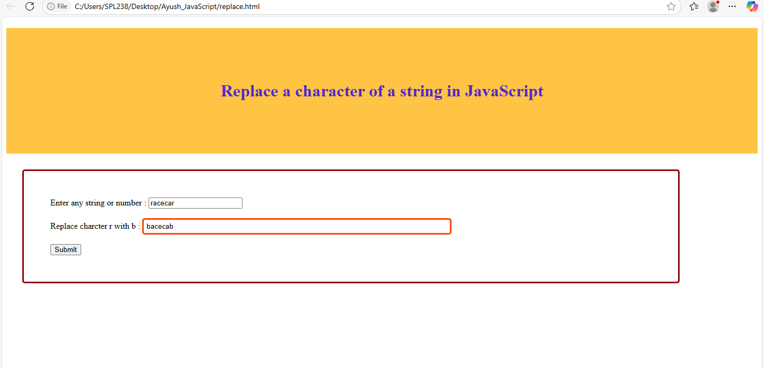

Palindrome of a String:
<!DOCTYPE html>
<html>
<head>
<title> program to reverse,replace a character of a string and check whether entered string is Palindrome in JavaScript </title>

<style>
h1 {
text-align: center;
padding: 100px;
background-color: blue;
color: white
}

.palin {
margin: 30px;
width: 80%;
border: 3px solid rgb(138, 9, 9);
border-radius: 5px;
padding: 50px;
}

#pa2 {

width: 50%;
border: 3px solid orangered;
border-radius: 5px;
padding: 5px;
}

#ra {

width: 50%;
border: 3px solid orangered;
border-radius: 5px;
padding: 5px;
}

#rc {

width: 50%;
border: 3px solid orangered;
border-radius: 5px;
padding: 5px;
}

</style>

</head>
<body>

<h1> Program to reverse,replace a character of a string and check whether entered string is Palindrome in JavaScript </h1>
<div class="palin">
<label> Enter any string or number : </label>
<input id= "pa"> <br> <br>

<label> Resultant string : </label>
<input id = "pa2" > </b> <br>
<button onclick= "palindrome();" >Submit</button> <br>
</div>

<script type = "text/javascript">

function palindrome()
{
var a= document.getElementById("pa").value;
// get the total length of the words

var b="";
// Use for loop to divide the words into 2 half
for (let i = a.length-1; i >=0; i--)
{
b+=a[i];
}
// validate the first and last characters are same
if (a==b)
document.getElementById("pa2"). value = b + " is a Palindrome String ";
else
document.getElementById("pa2"). value = b + " is not a Palindrome String";
}

</script>
</body>
</html> <!DOCTYPE html>
<html>
<head>
<title> program to reverse,replace a character of a string and check whether entered string is Palindrome in JavaScript </title>

<style>
h1 {
text-align: center;
padding: 100px;
background-color: rgba(255, 174, 0, 0.733);
color: rgba(44, 11, 231, 0.849)

}

.palin {
margin: 30px;
width: 80%;
border: 3px solid rgb(138, 9, 9);
border-radius: 5px;
padding: 50px;
}

#pa2 {

width: 50%;
border: 3px solid orangered;
border-radius: 5px;
padding: 5px;
}

#ra {

width: 50%;
border: 3px solid orangered;
border-radius: 5px;
padding: 5px;
}

#rc {

width: 50%;
border: 3px solid orangered;
border-radius: 5px;
padding: 5px;
}

</style>

</head>
<body>

<h1> Check whether entered string is Palindrome in JavaScript </h1>
<div class="palin">
<label> Enter any string or number : </label>
<input id= "pa"> <br> <br>

<label> Resultant string : </label>
<input id = "pa2" > </b> <br>
<button onclick= "palindrome();" >Submit</button> <br>
</div>

<script type = "text/javascript">

function palindrome()
{
var a= document.getElementById("pa").value;
// get the total length of the words

var b="";
// Use for loop to divide the words into 2 half
for (let i = a.length-1; i >=0; i--)
{
b+=a[i];
}
// validate the first and last characters are same
if (a==b)
document.getElementById("pa2"). value = b + " is a Palindrome String ";
else
document.getElementById("pa2"). value = b + " is not a Palindrome String";
}

</script>
</body>
</html>

